**The Raspberry Pi**

The Raspberry Pi is a series of small single-board computers developed in the United Kingdom by the Raspberry Pi Foundation.

[Operating system](https://www.google.com/search?q=raspberry+pi+operating+system&sa=X&ved=2ahUKEwiVodfM-p7pAhX363MBHRGuBZgQ6BMoADAtegQICBAC): [Android](https://www.google.com/search?q=Android&stick=H4sIAAAAAAAAAONgVuLSz9U3MCqvKEkvX8TK7piXUpSfmQIAyAsAJhgAAAA&sa=X&ved=2ahUKEwiVodfM-p7pAhX363MBHRGuBZgQmxMoATAtegQICBAD); [FreeBSD](https://www.google.com/search?q=FreeBSD&stick=H4sIAAAAAAAAAONgVuLQz9U3MKpMqVjEyu5WlJrqFOwCAOg-RnYWAAAA&sa=X&ved=2ahUKEwiVodfM-p7pAhX363MBHRGuBZgQmxMoAjAtegQICBAE); [Linux](https://www.google.com/search?q=Linux&stick=H4sIAAAAAAAAAONgVuLUz9U3SCuoqipYxMrqk5lXWgEATgerNhUAAAA&sa=X&ved=2ahUKEwiVodfM-p7pAhX363MBHRGuBZgQmxMoAzAtegQICBAF); [NetBSD](https://www.google.com/search?q=NetBSD&stick=H4sIAAAAAAAAAONgVuLQz9U3ME2xMFrEyuaXWuIU7AIA4T6kHBUAAAA&sa=X&ved=2ahUKEwiVodfM-p7pAhX363MBHRGuBZgQmxMoBDAtegQICBAG); [OpenBSD](https://www.google.com/search?q=OpenBSD&stick=H4sIAAAAAAAAAONgVuLQz9U3MM0pz13Eyu5fkJrnFOwCAL211REWAAAA&sa=X&ved=2ahUKEwiVodfM-p7pAhX363MBHRGuBZgQmxMoBTAtegQICBAH); [Plan 9](https://www.google.com/search?q=Plan+9&stick=H4sIAAAAAAAAAONgVuLQz9U3MDNML1zEyhaQk5inYAkAddSH0xUAAAA&sa=X&ved=2ahUKEwiVodfM-p7pAhX363MBHRGuBZgQmxMoBjAtegQICBAI); [RISC OS](https://www.google.com/search?q=RISC+OS&stick=H4sIAAAAAAAAAONgVuLUz9U3MDRLzy1fxMoe5BnsrOAfDABZQYGmFwAAAA&sa=X&ved=2ahUKEwiVodfM-p7pAhX363MBHRGuBZgQmxMoBzAtegQICBAJ); [Windows 10](https://www.google.com/search?q=Windows+10&stick=H4sIAAAAAAAAAONgVuLWz9U3MDQyKE_KrVjEyhWemZeSX16sYGgAAIqtrY8cAAAA&sa=X&ved=2ahUKEwiVodfM-p7pAhX363MBHRGuBZgQmxMoCDAtegQICBAK) [ARM64](https://www.google.com/search?q=ARM64&stick=H4sIAAAAAAAAAONgVuLQz9U3SE-rKl_EyuoY5GtmAgDFrFSbFAAAAA&sa=X&ved=2ahUKEwiVodfM-p7pAhX363MBHRGuBZgQmxMoCTAtegQICBAL); [Windows 10 IoT](https://www.google.com/search?q=Windows+10+IoT&stick=H4sIAAAAAAAAAONgVuLVT9c3NEw2LjcsrDAvWcTKF56Zl5JfXqxgaKDgmR8CAK37ZUgiAAAA&sa=X&ved=2ahUKEwiVodfM-p7pAhX363MBHRGuBZgQmxMoCjAtegQICBAM) Core

[Power](https://www.google.com/search?q=raspberry+pi+power&sa=X&ved=2ahUKEwiVodfM-p7pAhX363MBHRGuBZgQ6BMoADAuegQICRAC): 5V 3A (for full power delivery to [USB](https://www.google.com/search?q=USB&stick=H4sIAAAAAAAAAONgVuLQz9U3MC9PTlvEyhwa7AQAFmp7qRIAAAA&sa=X&ved=2ahUKEwiVodfM-p7pAhX363MBHRGuBZgQmxMoATAuegQICRAD) devices)

[Storage](https://www.google.com/search?q=raspberry+pi+storage&sa=X&ved=2ahUKEwiVodfM-p7pAhX363MBHRGuBZgQ6BMoADAvegQIChAC): MicroSDHC slot

[Memory](https://www.google.com/search?q=raspberry+pi+memory&sa=X&ved=2ahUKEwiVodfM-p7pAhX363MBHRGuBZgQ6BMoADAwegQICxAC)**:**1, 2, or 4 GiB LPDDR4-3200 RAM

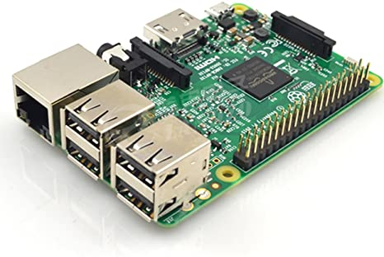

Fig :1 The Raspberry Pi

**Pi Cam:**

The Raspberry Pi Camera v2 is a high quality 8 megapixel Sony IMX219 image sensor custom designed add-on board for Raspberry Pi, featuring a fixed focus lens. 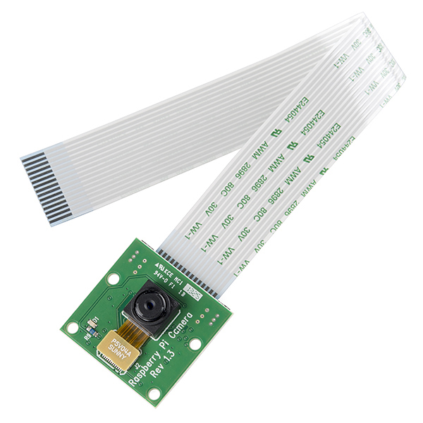

Fig; 2 Pi Cam

**Wi-Fi Module:**

The ESP8266 WiFi Module is a self contained SOC with integrated TCP/IP protocol stack that can give any microcontroller access to your WiFi network.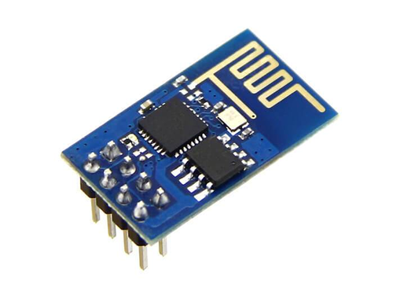

Fig:3 Wi-Fi Module.